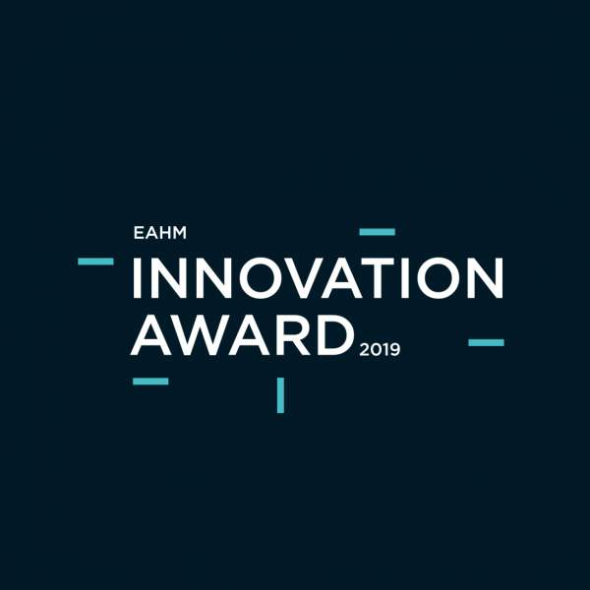
One of the main points foreseen by the EAHM Program 2019-2022 is to create an annual award for the best innovations implemented in European Hospitals.

The framework for the 2019 award will be a poster session at the EAHM Congress 2019 in Ghent

EAHM INNOVATION AWARD 2019
An abstract, maximum one per hospital, can be submitted until June 29th, 2019
(email submission to pascal.verdonck@ugent.be)
All abstracts will be reviewed by the international scientific committee of the EAHM.
The corresponding authors of the selected abstracts will be informed before July 1st, 2019 if they are accepted to present a A1 poster in the permanent poster session in Meet & Greet Center of the congress. All posters will be displayed the whole conference and a separate poster session will be organised on September 11th, 2019.
During the “get together session” on September 11th, 6-8 pm, the selected authors will have the opportunity to present the key result of their implemented innovation with one slide in one minute.
Based on the submitted abstract, the poster and the oral 1 minute pitch, the EAHM scientific committee will select the top three innovative projects and will award them, thanks to the sponsorship of all congress sponsors, with:
II First prize EAHM Innovation Award 2019 Value 2500 euro
II Second prize EAHM Innovation Award 2019 Value 1500 euro
II Third prize EAHM Innovation Award 2019 Value 1000 euro
All selected abstracts will be published on the EAHM website and the congress website after the 'get together' on Wednesday September 11th.
The plenary pitch session will be recorded and presented as a video on the EAHM and congress website.

AEDH-EVKM-EAHM – rue des Mérovingiens, 5 – L-8070 Bertrange (GDLux) -  +352 42 41 42 1 -  +352 42 41 42 81
ww.aedh.eu.org, www.evkm.eu.org, www.eahm.eu.org  sg@eahm.eu.org

EAHM INNOVATION AWARD 2019
TITLE OF PROJECT: AUTHOR INSTRUCTIONS FOR
ABSTRACT-POSTER SUBMISSIONS TO GHENT CONGRESS

[*] CEO’s name * , Collaborator , Collaborator, …
[*] 1name of hospital, adress, country[ * indicates presenting author ]

Keyword(s): smart buildings & logistics – big data & digital health – finance & health economics –innovation & technology – healing architecture – health management, governance & ethics, value based health care [Choose one or more (max. 2) topics from this list]

- INTRODUCTION

Title: The title should be centered, Arial or Helvetica, bold, 16 point, and in capitals LIKE THE LAST PART OF THIS SENTENCE. The abstract should incorporate the following sections: Introduction, Materials and Methods, and Results and Discussion.

Author information: The author’s name and affiliation should be centered, Arial or Helvetica, and 10 point.

Paper size: These instructions assume A4 paper. Papers should have a length of (at most) 1 page.

Margins: Left, right, top and bottom margins should be 25 mm. PLEASE DO NOT ALTER THESE MARGINS!

Columns: Text should be presented in two columns, each 83 mm wide.

Section heads: Section heads are flush left, Arial or Helvetica, bold, 10 point and in capitals. Section 1 head, “COMMON REQUIREMENTS” is an example.

  - Another Requirement

Subsection heads: If your abstract has subsections, they have to be flush left, Arial or Helvetica, bold, 10 point, and sub-numbered. Subsection “1.1 Another Requirement” is an example.

Text: All text including abstract should be single space, full justification, Arial or Helvetica, and 10 point.

2. MATERIALS AND METHODS
In this section, you describe the innovation project.
…
…
…
…
…
…
…
…
…
…
…

3. RESULTS AND DISCUSSION
This last section should give an overview of the obtained results, kpi’s and should contain a discussion about these results. In the last paragraph of this section, a conclusion is formulated.
…

All candidatures (in Word format) should be submitted online via email to pascal.verdonck@ugent.be

References
[Add a reference if relevant]

Contact address: name@email.cod

AEDH-EVKM-EAHM – rue des Mérovingiens, 5 – L-8070 Bertrange (GDLux) -  +352 42 41 42 1 -  +352 42 41 42 81
ww.aedh.eu.org, www.evkm.eu.org, www.eahm.eu.org  sg@eahm.eu.org

